**16-Bit Barrel Shifter**

ECE3300L.E01

Mohamed El-Hadedy Aly, Ph.D.

Miguel Alcala

Bryan Arciniega 011740664

Armen Barseghyan 013077363

Sahaj Bhakta 011926226

Richard Chear 013449683

July 31, 2020

**Introduction:**

This experiment is to design a 16-bit barrel shifter. The function of the barrel shifter is to manipulate and output a binary value through operations. These operations consist of either shifting or rotating bits by a desired amount. We also created an automatic up counter to the barrel shifter, that will increment the numbers of bits being shifted/rotated by one.Then producing the results onto four seven segments. The results display a total of 16 bits, each seven segments representing four bit input. This lab encompasses what we learned from all the other labs. Registers,bit manipulation, clock, seven segments and more were covered in this lab.

The schematic for this experiment is generated by Vivado, and is shown in Figure 1: 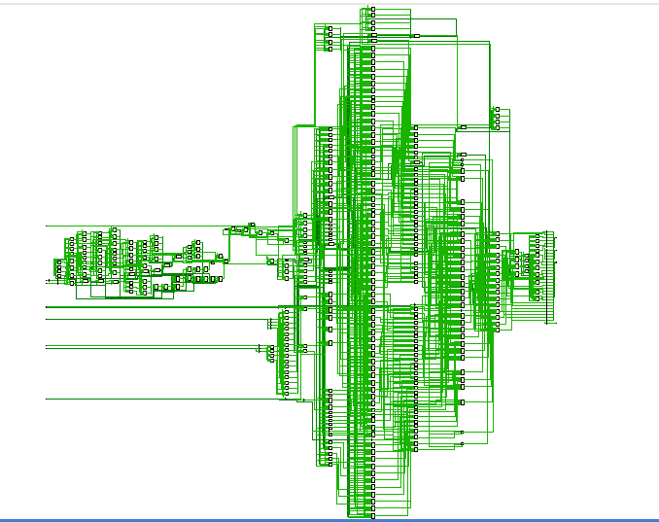

Figure 1: Schematic of the counter and seven segments.

**Experiment:**

How we tackled this lab is that we first had to figure out how to shift and rotate bits. Shifting bits is straight forward, but rotating bits is more challenging. How rotating bits work is that we store the value of the rotated bits into a register then shifted in the opposite direction. So the final answer will be A | B, which gives us the results that we expect.A problem we had is that we weren’t too sure on how the load and automatic functions will work, but we eventually interpreted our way and figured it out. We first created case statements for the load, if it’s zero then take the settings from the inputs and ignore the counter. With load being high then shift/rotate amounts are ignored. The settings from the input checks if it’s manual or auto, if it’s manual then we take the values of the switches. If it’s in auto mode then we would use the up counter to increment the number of bits being shifted by one. Next we used what we learned from the Alien calculator lab and used it in this lab. We created a clock and a case statement that would update the sevensements so fast that our eyes interpret all four seven segments being on and updating simatolously, since only one seven segment can be updated. Each seven segment will represent up to four bits, 0 to F.Unfortunately, our weak spot seems to be the testbench. We couldn’t get the simulation to run properly, we got a weird error not allowing us to compile the simulation.

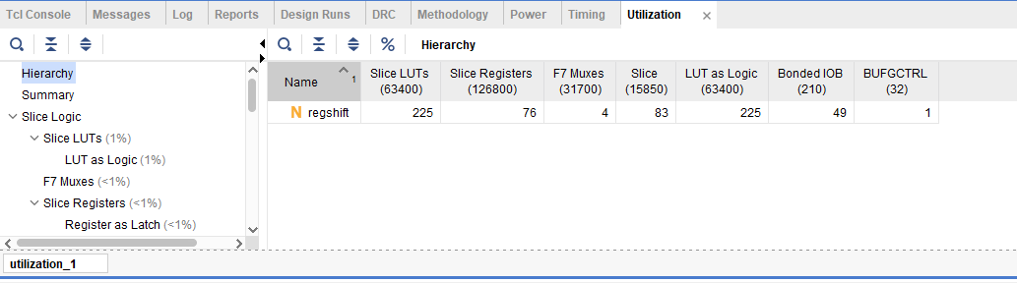

The resources of the board that were used in the experiment are shown in figure 3:

Figure 3: Resources used

**Conclusion:**

In conclusion we were able to build the 16-bit barrel shifter and upload it to the Artix-A7 board. All the shifts and rotations work wonderfully and are properly displaying onto the seven segments, with all cases tested. We even got a reset button to work. Unfortunately, the test bench did not come out the way we hoped, as it did not even compile. This was a good lab that required a lot of knowledge of FPGA design and a good understanding about seven segments,bit manipulation, registers, and clocks.